**Test Case 0044 (part 1)**

**System:** VirtuCardsClient & VirtuCardsHost

**Description:** test that checks if the profile data is being updated

**Severity:** 3

**Instructions**

1. Start VirtuCardClient application
2. Click the button labeled “Sign In”
3. Enter “virtucards01@gmail.com” into the text input labeled “Enter email…”
4. Enter “Testing1” into the text input labeled “Enter password…”
5. Press the button labeled “Login”
6. A window should appear saying “Login Success”
7. Press the OK button that appears on that window
8. Press the Profile Icon on the top left side

**Expected Result:** The user will be able to see his/her personal information and statistics such as games played, games won, and games lost.

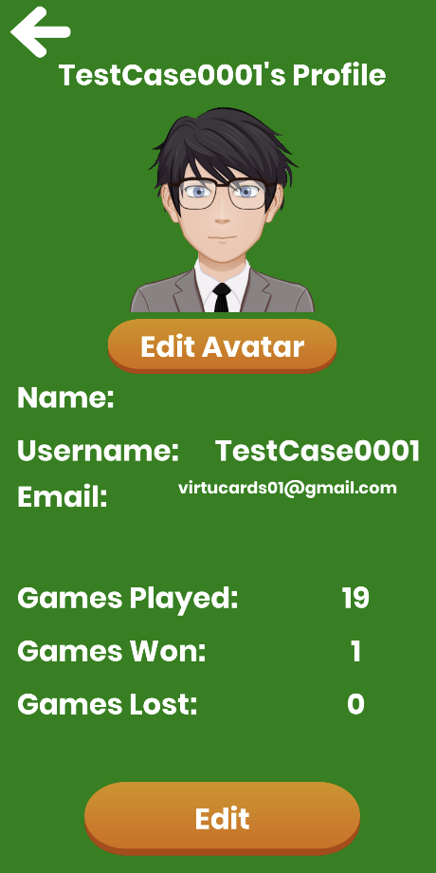

**Test Case 0044 (part 2)**

**System:** VirtuCardsClient & VirtuCardsHost

**Description:** test that checks if the profile data is being updated

**Severity:** 3

**Instructions**

1. Start VirtuCardClient application
2. Click the button labeled “Sign In”
3. Enter “virtucards01@gmail.com” into the text input labeled “Enter email…”
4. Enter “Testing1” into the text input labeled “Enter password…”
5. Press the button labeled “Login”
6. A window should appear saying “Login Success”
7. Press the OK button that appears on that window
8. Press the OK button that appears on that window
9. Press the Profile Icon on the top left side
10. Press back button
11. Repeat steps 2-7 with “[micro@soft.com](mailto:micro@soft.com)” and “Password!123”
12. Start VirtuCardHost application
13. Repeat steps 2-7 but on the VirtuCardHost application
14. The checkbox “Allow Host to Join” should be checked on the host
15. Press the Create Game button
16. In the VirtuCardClient application enter the 6-character room code found on the host’s screen into the field labeled “Enter Code…”
17. Press the Join Game button on the both clients
18. After the name TestCase0001 and billy123 appears in the player list on the host side, press the Start Game button
19. On the host side, end the game
20. Press the Profile Icon on the top left side

**Expected Result:** when the user has checked the games played before the game started, the game played count will increase by one after playing a game. As you can see the previous picture in part 1 shows 19 games played and this picture shows 20.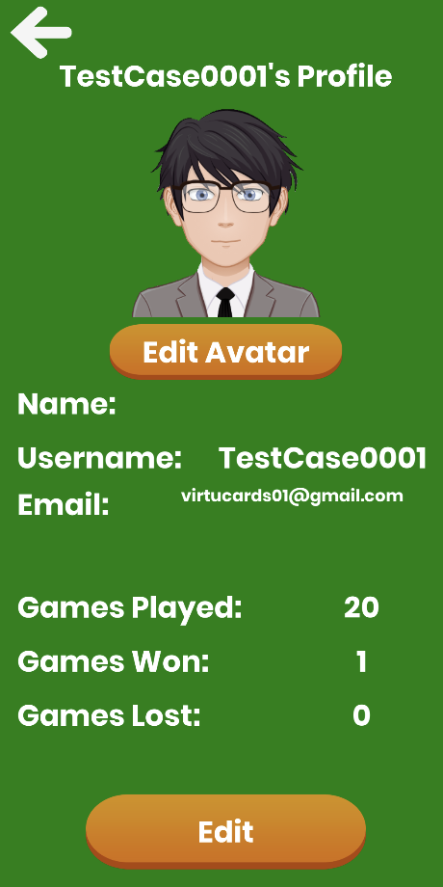

**Test Case 0044 (part 3)**

**System:** VirtuCardsClient & VirtuCardsHost

**Description:** test that checks if the profile data is being updated

**Severity:** 3

**Instructions**

1. Start VirtuCardClient application
2. Click the button labeled “Sign In”
3. Enter “virtucards01@gmail.com” into the text input labeled “Enter email…”
4. Enter “Testing1” into the text input labeled “Enter password…”
5. Press the button labeled “Login”
6. A window should appear saying “Login Success”
7. Press the OK button that appears on that window
8. Press the OK button that appears on that window
9. Press the Profile Icon on the top left side
10. Press back button
11. Repeat steps 2-7 with “[micro@soft.com](mailto:micro@soft.com)” and “Password!123”
12. Start VirtuCardHost application
13. Repeat steps 2-7 but on the VirtuCardHost application
14. The checkbox “Allow Host to Join” should be checked on the host
15. Press the Create Game button on “Freeplay”
16. In the VirtuCardClient application enter the 6-character room code found on the host’s screen into the field labeled “Enter Code…”
17. Press the Join Game button on the both clients
18. After the name TestCase0001 and billy123 appears in the player list on the host side, press the Start Game button
19. On the host side, declare TestCase0001 as a winner and end the game
20. Press the Profile Icon on the top left side

**Expected Result:** when the user is declared a winner, the stats should update +1 on the games played and +1 on the games won. The picture shown below shows that it has one more games played and games won than the previous test case.

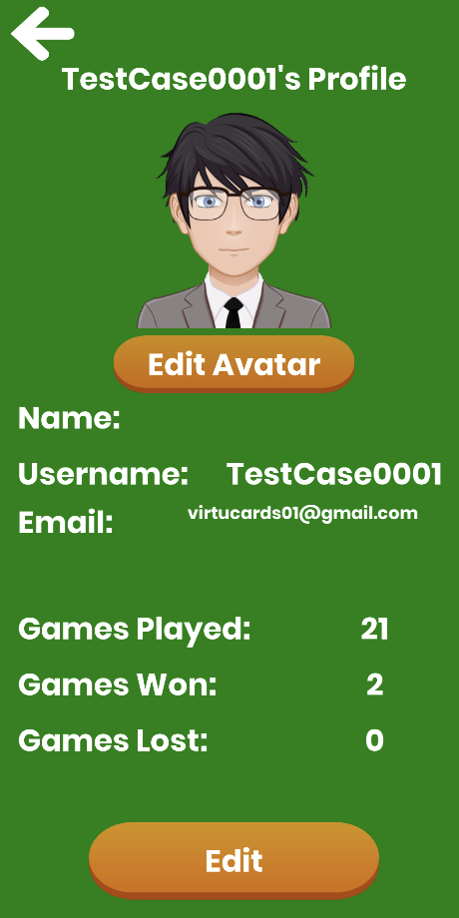

**Test Case 0044 (part 4)**

**System:** VirtuCardsClient & VirtuCardsHost

**Description:** test that checks if the profile data is being updated

**Severity:** 3

**Instructions**

1. Start VirtuCardClient application
2. Click the button labeled “Sign In”
3. Enter “virtucards01@gmail.com” into the text input labeled “Enter email…”
4. Enter “Testing1” into the text input labeled “Enter password…”
5. Press the button labeled “Login”
6. A window should appear saying “Login Success”
7. Press the OK button that appears on that window
8. Press the OK button that appears on that window
9. Press the Profile Icon on the top left side
10. Press back button
11. Repeat steps 2-7 with “[micro@soft.com](mailto:micro@soft.com)” and “Password!123”
12. Start VirtuCardHost application
13. Repeat steps 2-7 but on the VirtuCardHost application
14. The checkbox “Allow Host to Join” should be checked on the host
15. Press the Create Game button on “Freeplay”
16. In the VirtuCardClient application enter the 6-character room code found on the host’s screen into the field labeled “Enter Code…”
17. Press the Join Game button on the both clients
18. After the name TestCase0001 and billy123 appears in the player list on the host side, press the Start Game button
19. On the host side, declare billy123 as a winner and end the game
20. Press the Profile Icon on the top left side

**Expected Result:** when the user is not declared a winner, the stats should update +1 on the games played and +1 on the games won. The picture shown below shows that it has one more games played and games lost than the previous test case.